# CS 499 Module One Assignment Template

Complete this template by replacing the bracketed text with the relevant information.

1. **Self-Introduction: Address all of the following questions to introduce yourself.**
   1. **How long have you been in the Computer Science program?**

I have been in the Computer Science course since January of 2022.

* 1. **What have you learned while in the program? List three of the most important concepts or skills you have learned.**

The three most important concepts I have learned in this Computer Science course are various programming languages, problem-solving techniques such as breaking down code into smaller parts, and understanding the basic architecture of computers such as how they work.

* 1. **Discuss the specific skills you aim to demonstrate through your enhancements to reach each of the course outcomes**.

The specific skills that I aim to demonstrate are:

* + - * 1. **Software Design and Engineering-** Enhance the user interface to be more user-friendly and well-structured, offering better collaboration and communication among different users by allowing users and developers to interact with the software, which will help further decision-making for future enhancements. Developing a user-friendly user interface will deliver a visually attractive and functional design. Solve and improve the user interface and logic by applying algorithmic principles. Using Advanced SQL concepts such as indexing and cache will demonstrate my ability to use well-founded techniques to optimize database performance. Implementing database encryption will ensure the security and privacy of the data contained within.
        2. **Algorithms and Data structures—**Improve software efficiency by introducing a hash table in the database. It aligns with the course outcomes by enhancing performance and responsiveness using efficient data to support decision-making that provides readily available data to different audiences. It delivers coherent and context-appropriate communications to specific audiences. Introducing the hash tables involves applying algorithmic principles such as hashing functions. This aligns with designing solutions that solve a problem using principles and computer science practices. Hash tables are innovative techniques for enhancing data access and retrieval. When implementing the hash tables, the security measures to take are preventing unauthorized access to the hash table data and taking in what collision handling technique would best be suited for my artifact.
        3. **Databases-** Implementing indexes will improve the efficiency of accessing the data, which makes it more responsive and easier to use by different audiences. This builds a collaborative environment that supports organizational and team decision-making by making sure the data is readily available. Explaining how indexing will benefit this artifact throughout my documentation and visual aids will demonstrate my ability to communicate technical concepts. Indexing involves understanding the algorithmic principles to enhance data retrieval. The tradeoff is additional storage spaces for indexes versus the performance aspect and the benefits. Using indexes are advanced MySQl concepts and is an innovative technique that enhances query performance and improves the software's efficiency. While applying indexing, ensure that the operation is of high integrity and is protected against unauthorized access.
  1. **How do the specific skills you will demonstrate align with your career plans related to your degree?**

These skills align with my career plans to become a software engineer. These skills will enable me to handle complex problems. Enhance performance and design reliable, scalable software, which are important skills for this career title.

* 1. **How does this contribute to the specialization you are targeting for your career?**

This contributes to my specialization by applying design best practices to a manageable, scalable, maintainable, and strong design. It enhances my skill set and makes me a valuable asset to any organizational team. This also helps with my career growth in the software engineering field.

1. **ePortfolio Set Up:**
   1. **Submit a screen capture of your ePortfolio GitHub Pages home page that clearly shows your URL.** 
      1. **You already have a repository in GitHub where you uploaded projects in previous courses. Your ePortfolio will reside in GitHub but can link to work at other sites, such as Bitbucket.**

* 1. **Use the GitHub Pages link in the Resource section for directions on:**
     1. **How to create your GitHub website and publish code to GitHub Pages**
     2. **Issues, such as adding links to other sites**
  2. **Paste a screenshot of your GitHub Pages home page with your URL clearly showing in the space below.**

1. **Enhancement Plan:** 
   1. **Category One: Software Engineering and Design**
      1. **Select an artifact that is aligned with the software engineering and design category and explain its origin. Submit a file containing the code for the artifact you choose with your enhancement plan.**

**CS-360 Mobile Architecture and Programming**

The artifact that I have chosen and that aligns with the software engineering and design category is from the CS-360 Mobile Architecture and Programming course. It is the Events Calendar Tracking app. This artifact is a calendar app where users can create events, edit events, delete events, view events, and set automatic reminders about upcoming events.

**Note: Your artifact may be work from the following courses:**

* **IT 145: Foundation in Application Development**
* **CS 250: Software Development Lifecycle**
* **CS 260: Data Structures and Algorithms**
* **IT 315: Object Oriented Analysis and Design**
* **CS 320: Software Testing, Automation, and Quality Assurance**
* **CS 330: Computational Graphics and Visualization**
* **CS 340: Advanced Programming Concepts**
* **CS 350: Emerging Systems Architectures and Technologies**
* **CS 360: Mobile Architecture and Programming**
* **IT 365: Operating Environments**
* **IT 380: Cybersecurity and Information Assurance**
* **CS 405: Secure Coding**
* **CS 410: Reverse Software engineering**
* **IT 340: Network and Telecommunication Management**
* **IT 380: Cybersecurity and Information Assurance**
  + 1. **Describe a practical, well-illustrated plan for enhancement in alignment with the category, including a pseudocode or flowchart that illustrates the planned enhancement.**

**Objective:** Improve user interface by adding a forgot password feature.

* Design the forgot password screen
* Update the logic to include the new screen
* Implement the backend logic for password recovery.
* Clean up comments or add additional comments.

**For this category of enhancement, consider improving a piece of software, transferring a project into a different language, reverse engineering a piece of software for a different operating system, or expanding a project’s complexity. These are just recommendations. Consider being creative and proposing an alternative enhancement to your instructor.**

**Think about what additions to include to complete the enhancement criteria in this category. Since one example option is to port to a new language, that is the kind of scale that is expected. This does not mean you need to port to a new language but instead have an equivalent scale of enhancement. Underlying expectations of any enhancement include fixing errors, debugging, and cleaning up comments, but these are not enhancements themselves.**

* + 1. **Explain how the planned enhancement will demonstrate specific skills and align with course outcomes.** 
       1. **Identify and describe the specific skills you will demonstrate that align with the course outcome.**
* Problem-Solving- I will develop solutions to complex problems by using concepts and methodologies that I have learned throughout my time in this program. It will show that I can think creatively and apply logic.
* Technical- I can show proficiency in using industry tools, technologies, and techniques that will show my ability to apply practical knowledge.
* Communication- I will be able to show my ability to communicate my ideas and solutions through oral and written documentation.
* Logic- I will be able to analyze and identify problems and possible solutions that can build my enhancement.
  + - 1. **Select one or more of the course outcomes below that your enhancement will align with**.

Due to its complexity and the insertion of data structures in conjunction with my visual and written communications, I believe that my enhancement will align with all five of the course outcomes. The enhancement will demonstrate innovative solutions to problems where I apply concepts learned in this program while keeping security at the forefront.

**Course Outcomes:**

1. **Employ strategies for building collaborative environments that enable diverse audiences to support organizational decision-making in the field of computer science.**
2. **Design, develop, and deliver professional-quality oral, written, and visual communications that are coherent, technically sound, and appropriately adapted to specific audiences and contexts.**
3. **Design and evaluate computing solutions that solve a given problem using algorithmic principles and computer science practices and standards appropriate to its solution while managing the trade-offs involved in design choices.**
4. **Demonstrate an ability to use well-founded and innovative techniques, skills, and tools in computing practices for the purpose of implementing computer solutions that deliver value and accomplish industry-specific goals.**
5. **Develop a security mindset that anticipates adversarial exploits in software architecture and designs to expose potential vulnerabilities, mitigate design flaws, and ensure privacy and enhanced security of data and resources.**
   1. **Category Two: Algorithms and Data Structures**
6. **Select an artifact that is aligned with the algorithms and data structures category and explain its origin. Submit a file containing the code for the artifact you choose with your enhancement plan. You may choose work from the courses listed under Category One.**

**CS-360 Mobile Architecture and Programming**

The artifact that I have chosen and that aligns with the software engineering and design category is from the CS-360 Mobile Architecture and Programming course. It is the Events Calendar Tracking app. This artifact is a calendar app where users can create events, edit events, delete events, view events, and set automatic reminders about upcoming events.

1. **Describe a practical, well-illustrated plan for enhancement in alignment with the category, including a pseudocode or flowchart that illustrates the planned enhancement.**

**Objective:** Improve software efficiency by introducing a hash table in the database.

* Identify the data elements that will serve as keys and values in the hash table.
* Design the hash function
* Implement the function
* Transfer existing data to the hash table format
* Test the hash table to make sure it performs as expected using industry tools.
* Adjust the hash function that can enhance performance
* Add any comments to the code.

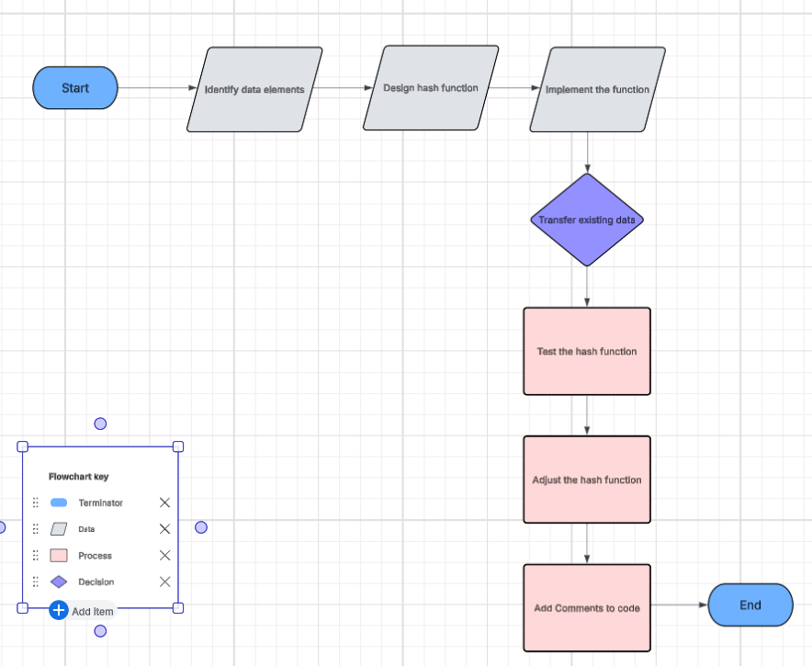

**For this category of enhancement, consider improving the efficiency of a project or expanding the complexity of the use of data structures and algorithms for your artifact. These are just recommendations. Consider being creative and proposing an alternative enhancement to your instructor. Note: You only need to choose one type of enhancement per category.**

**Think about what additions to include to complete the enhancement criteria in this category. Since one example option is to port to a new language, that is the kind of scale that is expected. Perhaps you might increase the efficiency and time complexity of an algorithm in an application and detail the logic of the increased time complexity. Remember, you do not need to port to a new language but instead have an equivalent scale of enhancement. Underlying expectations of any enhancement include fixing errors, debugging, and cleaning up comments, but these are not enhancements themselves.**

1. **Explain how the planned enhancement will demonstrate specific skills and align with course outcomes.** 
   1. **Identify and describe the specific skills you will demonstrate to align with the course outcome.**

The specific skills I will demonstrate to align with the course outcomes are:

* Implementing a hash table, that is, a basic data structure that will enhance data retrieval.
* Design and analyze algorithms to make sure the hash table performs efficiently.
* Use optimization techniques to improve the performance of the database by integrating the hash table.
* Show proficiency in SQL by writing queries that interact with the hash table.
* Code, test, and debug to make sure this enhancement works well with other components.
  1. **Select one or more of the course outcomes listed under Category One that your enhancement will align with.**

My enhancements will align with the course outcomes by optimizing an algorithmic design that meets the requirements and tradeoffs for space vs time which will align with design and evaluate computing solutions that solve a given problem using algorithmic principles and computer science practices and standards appropriate to its solution while managing the trade offs involved in the design choice. By using tools such as Junit to test my hash functions and using advanced data structures and database management tools, I will show my ability to use well-founded and innovative techniques, skills, and tools in computing practices to implement computer solutions that deliver value and accomplish industry-specific goals.

* + 1. **Select an artifact that is aligned with the databases category and explain its origin. Submit a file containing the code for the artifact you choose with your enhancement plan. You may choose work from the courses listed under Category One.**

**CS-360 Mobile Architecture and Programming**

The artifact that I have chosen and that aligns with the software engineering and design category is from the CS-360 Mobile Architecture and Programming course. It is the Events Calendar Tracking app. This artifact is a calendar app where users can create events, edit events, delete events, view events, and set automatic reminders about upcoming events.

* + 1. **Describe a practical, well-illustrated plan for enhancement in alignment with the category, including a pseudocode or flowchart that illustrates the planned enhancement.**

**Objective:** Implement Cache system to work in conjunction with the hash tables.

* Implement cache structure
* Check cache before querying the database
* Database query
* Add, update, delete users and events
* Synchronize data
* Testing
* Add code comments

**PSEUDOCODE**

Pseudocode

//introduce using HashMap

userCache = new Hashmap<String, User> ()

eventCache = new HashMap<Integer, Event>()

//Function to retrieve user from cache or the database

Function getUser(username);

//1st Step Check Cache for User

IF username EXISTS in userCache;

RETURN userCache[username]

ELSE;

//2nd Step Query database for user

User = Query SQL Database WHERE username = ‘username’

IF user EXISTS in database;

// 3rd Step Cache user

userCache.put(username, user)

RETURN user

// Function to retrieve an event from cache or database

Function getEvent(eventide);

// 1st Step check cache for event

IF eventide EXISTS in eventCache;

RETURN eventCache[eventID]

ELSE;

//2nd Step Query database for event

Event = Query SQL database WHERE eventID = ‘eventID’

IF event EXISTS in database;

// 3rd Step cache event

eventCache.put(eventID, Event)

RETURN event

// Function to add new user to database and cache

Function addUser(user);

//1st Step add user to database

INSERT User data

//2nd Step add user to cache

userCache.put(user.getUsername(),user)

//Function to add new event to database and cache

Function addEvent(event);

//1st Step Add event to database

INSERT eventData

// 2nd step Add event to cache

eventCache.put(event.getID(), event)

// Function to update existing user in database and cache

Function updateUser(user);

//1st Step Update user in database

UPDATE userData WHERE username ‘ ‘user.getUsername()’

//2nd Step Update user in Cache

userCache.put(user.getUsername(), user)

//Function to update existing event in database and cache

Function updateEvent(event);

//1st Step Update event in database

UPDATE eventData WHERE eventID = ‘event.getID()’

// 2nd Step update evnt in cache

eventCache.put(event.getID(), event)

//Function to delete user from database and cache

Function deleteUser(username);

//1st Step delete user from database

DELETE User WHERE username =’username’

//2nd Step delete user from cache

userCache.remove(username)

//Function to delete event from database and cache

Function deleteEvent(eventID);

//1st Step delete event from database

DELETE Event WHERE eventID =’eventID’

//2nd Step delete event from cache

eventCache.remove(eventID)

**For this category of enhancement, consider adding more advanced concepts of MySQL, incorporating data mining, creating a MongoDB interface with HTML/JavaScript, or building a full stack with a different programming language for your artifact. These are just recommendations; consider being creative and proposing an alternative enhancement to your instructor. Note: You only need to choose one type of enhancement per category.**

**Think about what additions to include to complete the enhancement criteria in this category. Since one example option is to port to a new language, that is the kind of scale that is expected. Perhaps you might increase the efficiency and time complexity of an algorithm in an application and detail the logic of the increased time complexity. Remember, you do not need to port to a new language but instead have an equivalent scale of enhancement. Underlying expectations of any enhancement include fixing errors, debugging, and cleaning up comments, but these are not enhancements** **themselves.**

* + 1. **Explain how the planned enhancement will demonstrate specific skills and align with course outcomes.** 
       1. **Identify and describe the specific skills you will demonstrate that align with the course outcome.**

The specific skills I will demonstrate to align with the course outcomes are:

* Cache Impimentation
* Understanding of hash Tables and Cache
* Optimizing performance
* Synchronizing and managing databases
* Architecture and system design
* Software testing and debugging
* Problem solving
  + - 1. Select one or more of the course outcomes listed under Category One that your enhancement will align with.

My enhancement will align with the course outcome of designing and evaluating computing solutions that solve a given problem using algorithmic principles and computer science practices and standards appropriate to its solution while managing the trade-offs involved in the design choices because implementing hash tables with cache eviction strategies will enhance the data retrieval and memory usage. It will follow the best practices in terms of efficiency, maintainability, and consistency.

1. **ePortfolio Overall Skill Set**
   1. **Accurately describe the skill set to be illustrated by the ePortfolio overall.**
      1. **Skills and outcomes planned to be illustrated in the code review**

* Demonstrated the ability to design and implement algorithms such as hash tables and Cache systems that improve performance and data retrieval while reducing the load on the database.
* Understanding of data structures and how they are applied. How they enhance performance, data seeds, and storage management.
* Hightlight problem-solving skills that address issues that are potential with system performance and data consistency.
  + 1. **Skills and outcomes planned to be illustrated in the narratives**

The narrative section will highlight how key design choices were made, showcasing problem-solving, system design, and technical knowledge. It will address what improvements were made throughout the enhancement process.

* + 1. **Skills and outcomes planned to be illustrated in the professional self-assessment**

In this section, I will focus on how I met the course objectives, what challenges I faced, and what I could have possibly done better. What new skills I developed in the process. How this has helped my growth.

**References**

Patel, D. (2024, August 16). *Essential Collision Handling Techniques in Hashing*. Darsh’s Blog. https://darsh-patel.hashnode.dev/collision-handling-techniques-in-hashing-you-need-to-know

‌